**Phase 6: User Interface Development**

**Goal :** To design and implement a user-friendly interface in Salesforce using Lightning tools, LWCs, and Apex integration, enabling users to interact with data efficiently and navigate seamlessly through the application.

**1.Lightning App Builder**

* **Purpose:** Drag-and-drop tool to create custom pages without coding.
* **Key Uses:** Build **App Pages**, **Home Pages**, and **Record Pages**.
* **Details:** Place standard components or custom LWCs, save, and activate for users.

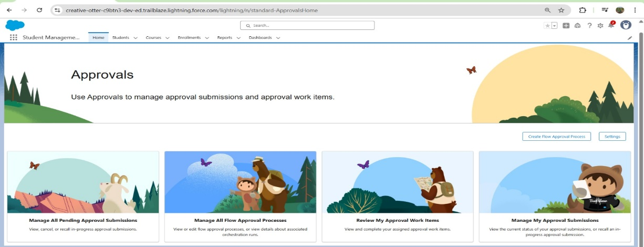

**2.Record Pages**

* **Purpose:** Customize the layout of individual records.
* **Key Uses:** Display key fields, related lists, and custom LWCs for objects like Student or Course.
* **Details:** Assign pages to apps or profiles to control visibility.

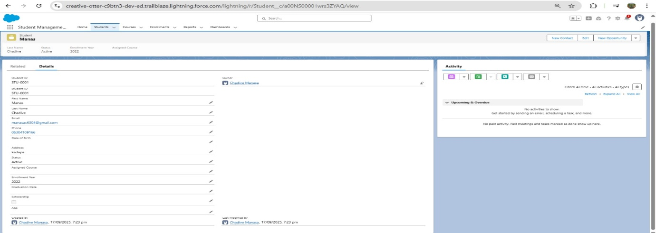

**3.Tabs**

* **Purpose:** Organize objects, pages, or components into tabs for easy navigation.
* **Key Uses:** Access **Students, Courses, Reports**, or custom pages quickly.
* **Details:** Tabs can host objects, Visualforce pages, web pages, or LWCs.

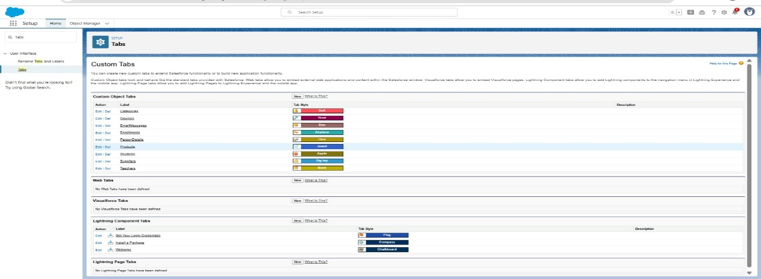

**4. Home Page Layouts**

* **Purpose:** Customize the Home Page for better user experience.
* **Key Uses:** Show dashboards, reports, navigation buttons, and custom LWCs.
* **Details:** Layouts define the structure and visibility of components on the Home Page.

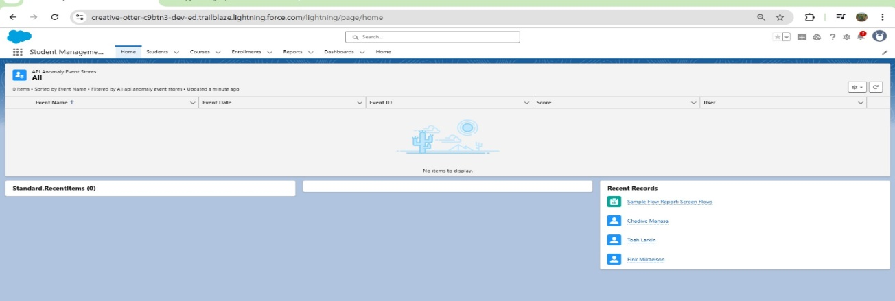

**5. Utility Bar**

* **Purpose:** Quick access to frequently used tools at the bottom of the app.
* **Key Uses:** Add Notes, Messages, or custom LWCs for easy reach.
* **Details:** Can configure behavior, size, and component order.

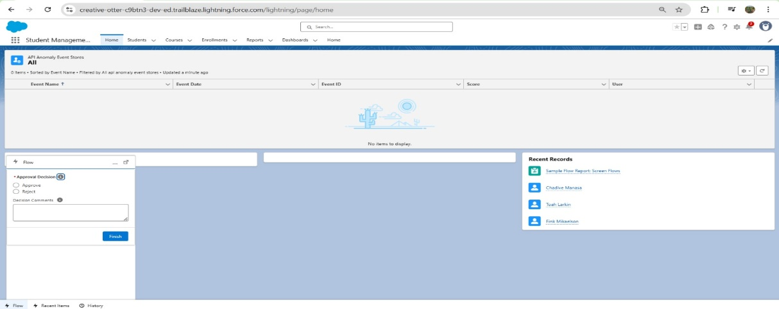

**6. Lightning Web Components (LWC)**

* **Purpose:** Build reusable, interactive components for the UI.
* **Key Uses:** Display student lists, details, assignments, certificates, and navigation buttons.
* **Details:** Components consist of HTML (template), JS (functionality), CSS (styling), and meta file (configuration).

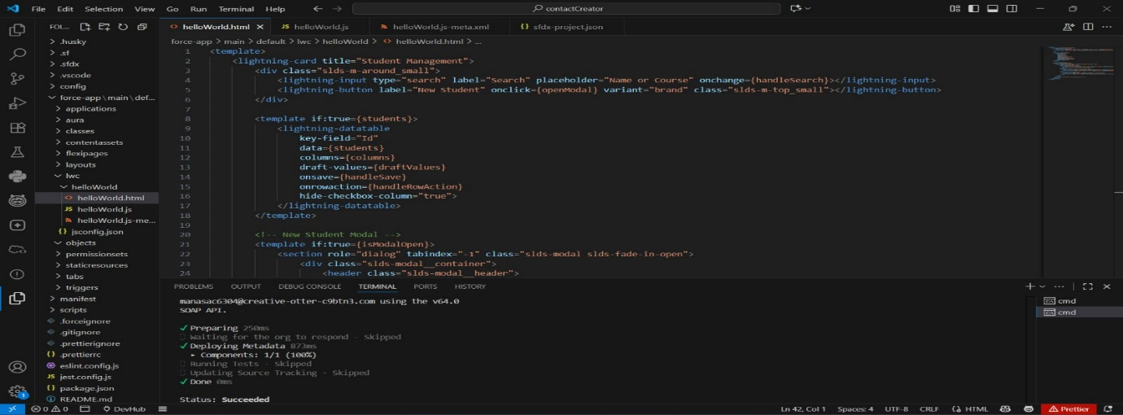

**7. Apex with LWC**

* **Purpose:** Fetch or manipulate Salesforce data using Apex in LWCs.
* **Key Uses:** Display dynamic data like students or courses.
* **Details:** Use **@AuraEnabled methods** in Apex, then call them in JS (Wire or Imperative).

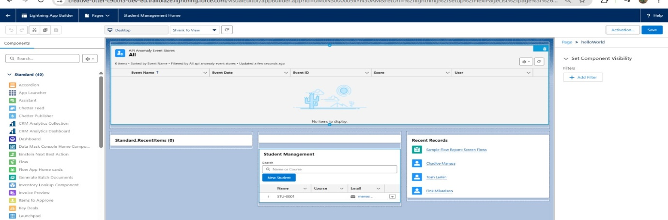

**8. Events in LWC**

* **Purpose:** Enable communication between components.
* **Key Uses:** Pass data from child to parent, or across sibling components.
* **Details:** Use **Custom Events** (dispatchEvent) or **Lightning Message Service** for cross-component communication.

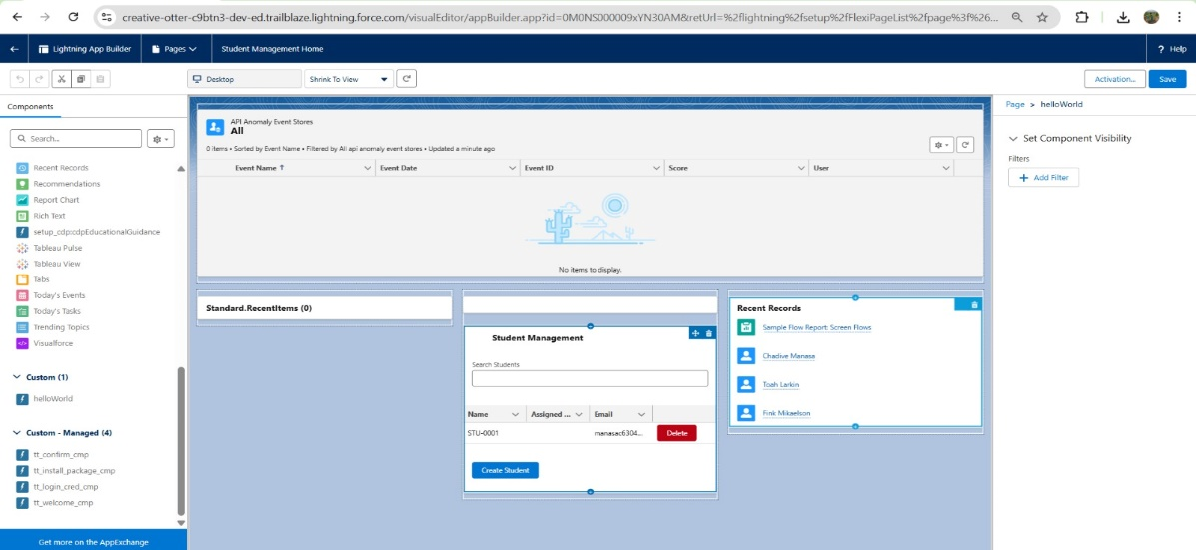

**9. Wire Adapters**

* **Purpose:** Automatically fetch Salesforce data reactively.
* **Key Uses:** Display records or lists without manual refresh.
* **Details:** Example: @wire(getRecord, { recordId: '$recordId', fields }) record;

**10. Imperative Apex Calls**

* **Purpose:** Call Apex methods manually from JS when needed.
* **Key Uses:** Fetch or update data on button click or action.
* **Details:** Example:

import getStudents from '@salesforce/apex/StudentController.getStudents';

handleLoadStudents() {

getStudents()

.then(result => { this.students = result; })

.catch(error => { this.error = error; });

}

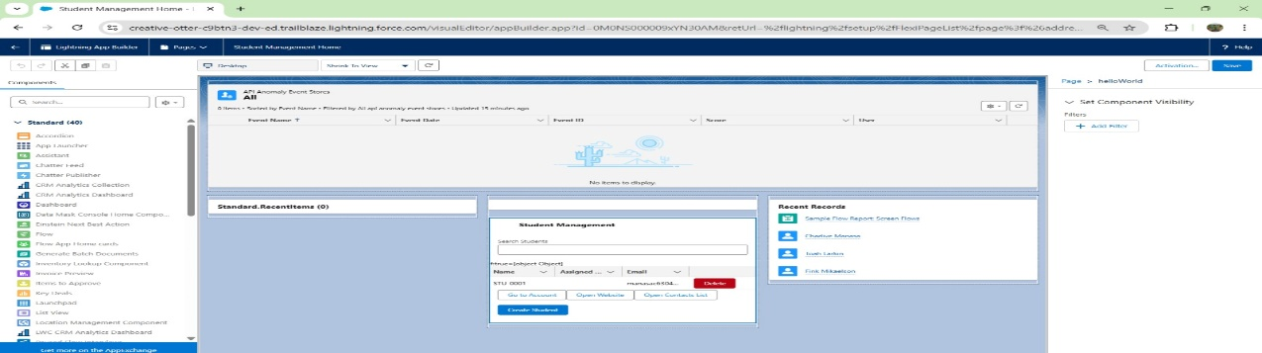

**11. Navigation Service**

* **Purpose:** Programmatically navigate to records, lists, or external URLs.
* **Key Uses:** Navigate users to **Student details, Course list, or external websites**.
* **Details:** Use NavigationMixin.Navigate() inside LWC methods. Works on **App Pages and Record Pages**, but not standard Home Pages.